**Admin Console Bug Fixes with screenshots**

|  |  |  |  |  |  |  |  |  |  |
| --- | --- | --- | --- | --- | --- | --- | --- | --- | --- |
| **Sheet Name** | **Description** | **Test Steps** | **Expected Output** | **Original Status** | **TechPundits Test Results** | **TechPundits Comments** | **TechPundits Bug Fixes** | **Test Results Post Bug Fix** | **Comments Post Bug Fix** |
| General Setting | Verify prevention of invalid file type in image fields | 1. Navigate to the site settings page. 2. Attempt to upload a video or audio file in an image field. 3. Click the 'Submit' button. | The application should prevent the upload and display an error message indicating invalid file type. | **Pass** | **Fail** | Any file type (.docx, .pdf, .txt, .csv, .gz, .rar)  is being accepted and the message 'Site settings have been updated successfully' is being displayed on clicking the 'Submit' button | **Fixed** | **Pass** | Accepts only image files - Has been tested locally only |

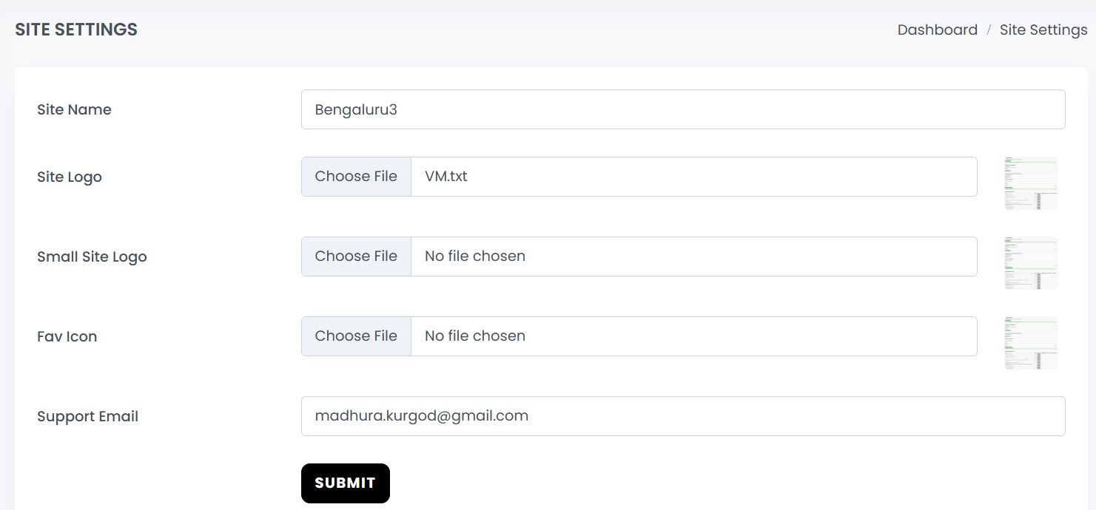

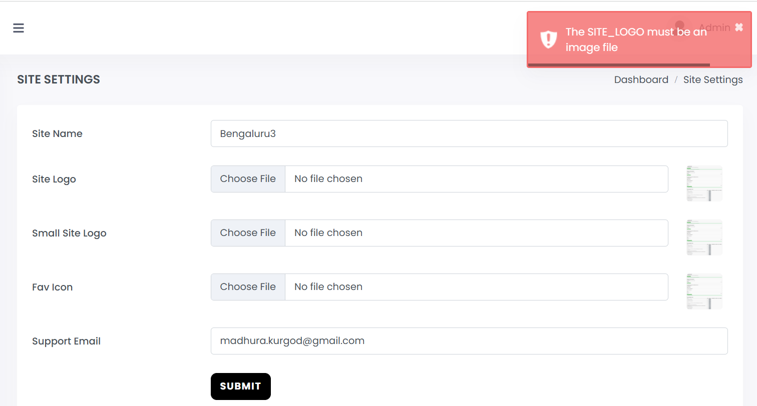

|  |  |  |  |  |  |  |  |  |  |
| --- | --- | --- | --- | --- | --- | --- | --- | --- | --- |
| **Sheet Name** | **Description** | **Test Steps** | **Expected Output** | **Original Status** | **TechPundits Test Results** | **TechPundits Comments** | **TechPundits Bug Fixes** | **Test Results Post Bug Fix** | **Comments Post Bug Fix** |
| General Setting | Verify validation for invalid email format | 1. Navigate to the site settings page. 2. Enter an invalid email address in the email field. 3. Click the 'Submit' button. | A validation message should appear indicating the invalid email format, and the settings should not be updated. | **Pass** | **Fail** | (User@gmail, .john@example.com)-> Accepted   (User.gmail.com, @gmail.com, gmail.com, user@, user yahoo.com,  .john@yahoo.com, john@-domain.com, john@.com  john..doe@example.com, john@.com, john@domain-.com, john@  john@domain..co.uk, user) -> Please enter a valid email address | **Fixed** | **Pass** | Checks for strict email format - Has been tested locally only |

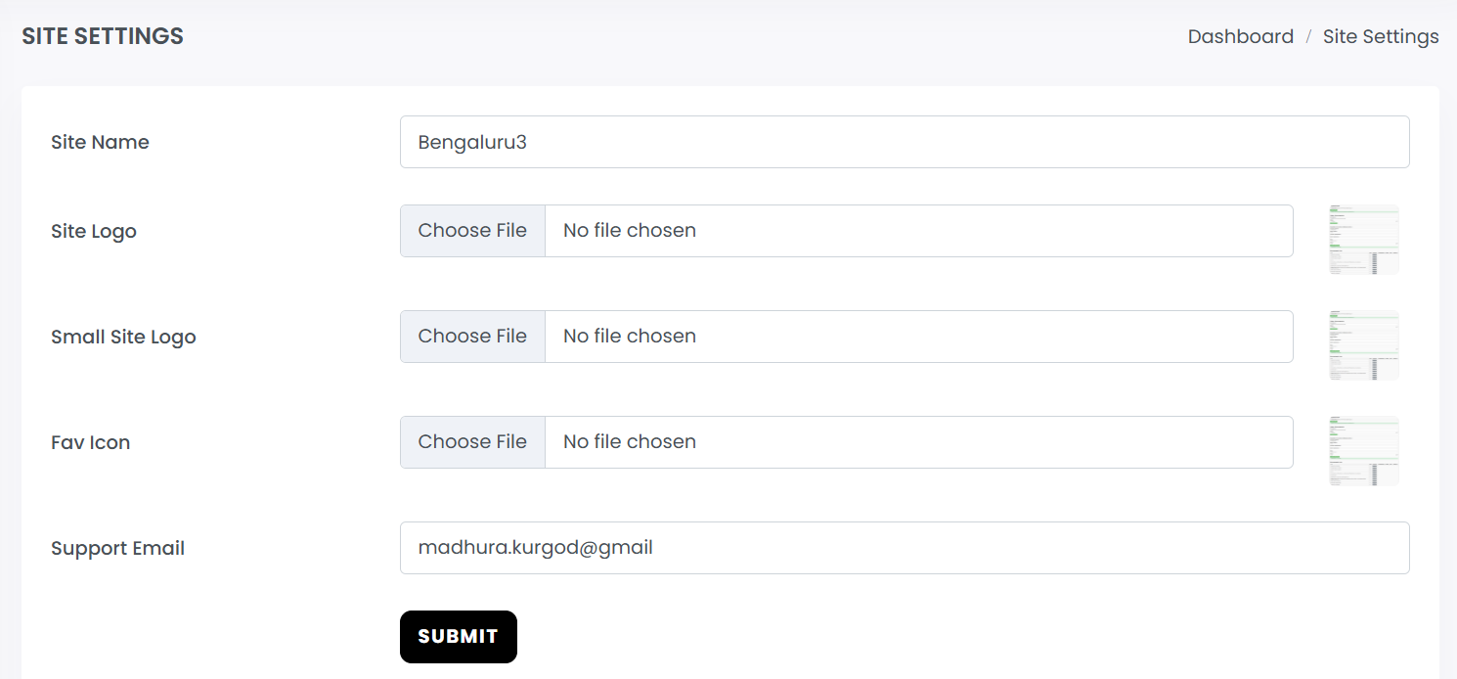

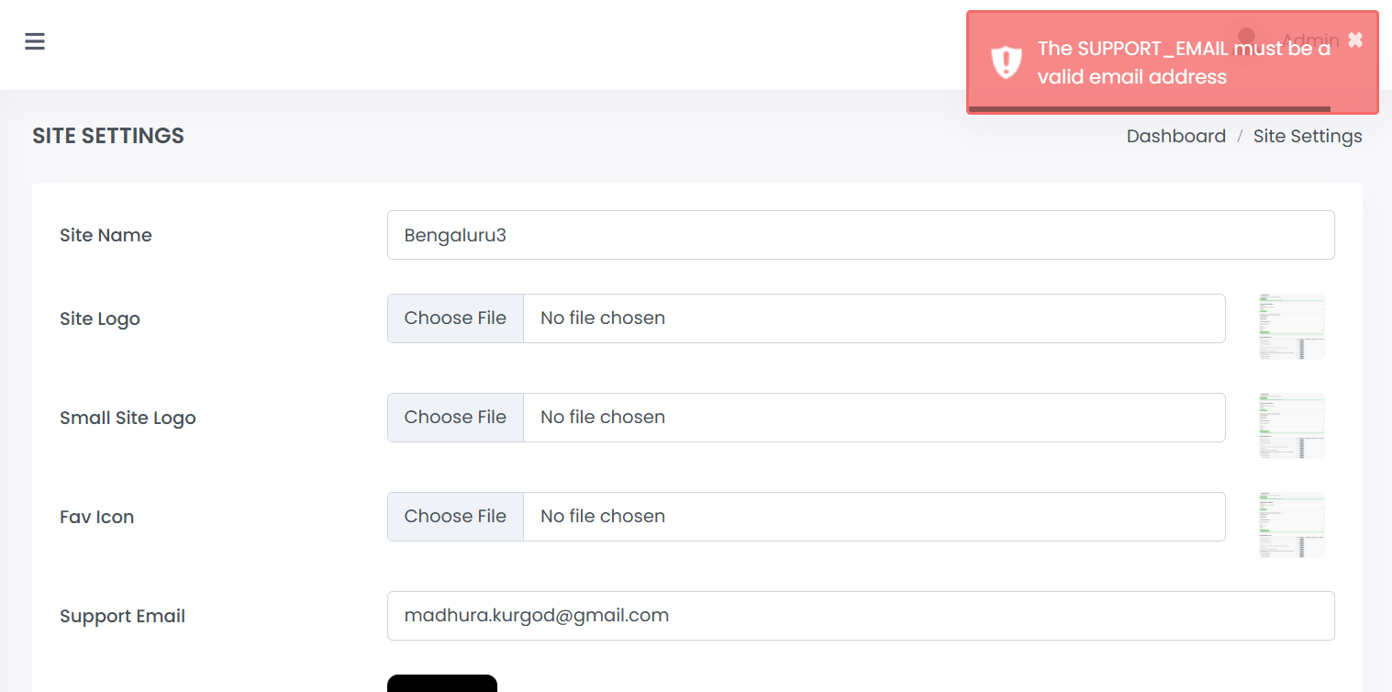

|  |  |  |  |  |  |  |  |  |  |
| --- | --- | --- | --- | --- | --- | --- | --- | --- | --- |
| **Sheet Name** | **Description** | **Test Steps** | **Expected Output** | **Original Status** | **TechPundits Test Results** | **TechPundits Comments** | **TechPundits Bug Fixes** | **Test Results Post Bug Fix** | **Comments Post Bug Fix** |
| Logout | Verify after clicking on the back button and perfrom any action | 1. Click on the back button 2. Click on any of the option | User is logged out from the admin panel and redirected to the login page. | **Pass** | **Fail** | When 'Logout' button is clicked, user is redirected to login page. And, when the back button is clicked and changes are made, for example, to the Site Name and 'Submit' button is clicked, the following alert message is displayed:   DataTables warning: table id=users-table - Invalid JSON response. For more information about this error, please see http://datatables.net/tn/1  Subsequent operations are not performed and user is redirected to login page. | **Fixed** | **Pass** | When 'Logout' button is clicked and then the browser's back button is clicked, user is redirected to previous dashboard page, but will not be able to continue with further operations, as it redirects him back to login screen  - Has been tested locally only |

**NOTE:** When ‘Logout’ button is clicked and then the browser’s back button is clicked, user is navigated to the dashboard. He can click on some links in it, but is immediately redirected to the login page.

|  |  |  |  |  |  |  |  |  |  |
| --- | --- | --- | --- | --- | --- | --- | --- | --- | --- |
| **Sheet Name** | **Description** | **Test Steps** | **Expected Output** | **Original Status** | **TechPundits Test Results** | **TechPundits Comments** | **TechPundits Bug Fixes** | **Test Results Post Bug Fix** | **Comments Post Bug Fix** |
| ForgotReset Password | Verify reset link usage after successful reset | 1. Complete the password reset process successfully 2. Try to use the same reset link again | 1. The reset link should be invalidated after successful use 2. Attempting to use it again should result in an error message 3. User should be directed to request a new reset link if needed | **Pass** | **Fail** | When the same reset link is used again, it accepts the new and confirm passwords. When the Reset Password is clicked, it displays the message 'Invalid Password Token' User is not directed to request a new reset link. — should not even allow for reopening of same reset link after use, should also time out after some time. | **Fixed** | **Pass** | When the same reset link is used again, it displays the message 'Invalid reset token' and user is directed to request a new reset link - Has been tested locally only with MAIL_MAILER=log (for testing purpose) |

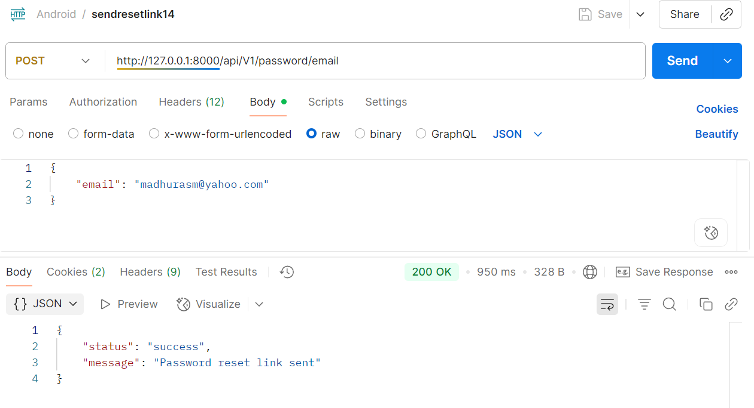

When a previously used link is clicked, it displays the message ‘Invalid or expired token’

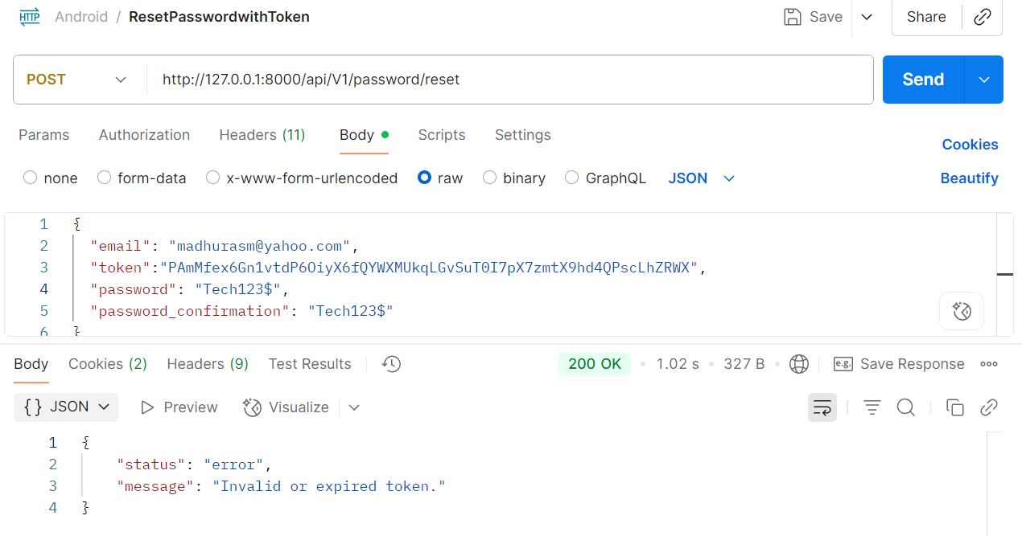

When link is used for the first time, it resets the password successfully

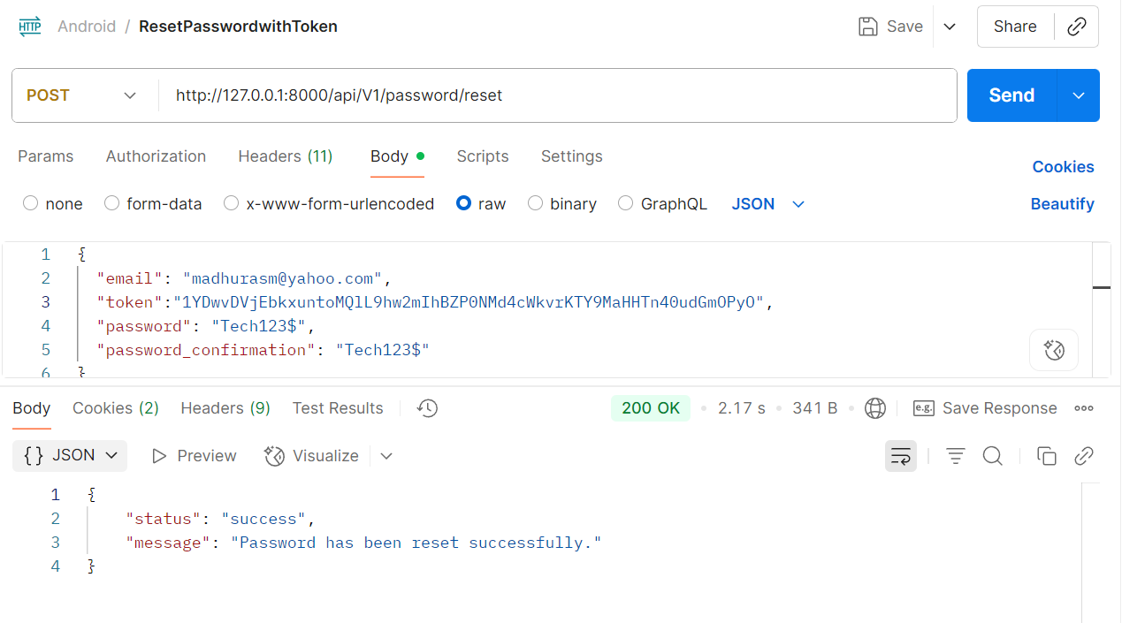

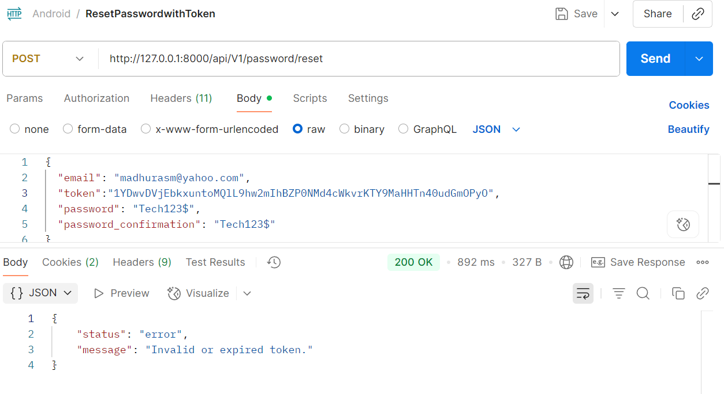

|  |  |  |  |  |  |  |  |  |  |
| --- | --- | --- | --- | --- | --- | --- | --- | --- | --- |
| **Sheet Name** | **Description** | **Test Steps** | **Expected Output** | **Original Status** | **TechPundits Test Results** | **TechPundits Comments** | **TechPundits Bug Fixes** | **Test Results Post Bug Fix** | **Comments Post Bug Fix** |
| ForgotReset Password | Verify UI elements on the reset password page | 1. Navigate to the reset password page via the link received in email 2. Observe all UI elements on the page | 1. Page should have fields for new password and confirm password 2. Page should have a submit/save button 3. Password requirements should be clearly displayed 4. All elements should be properly aligned and formatted | **Pass** | **Fail** | The reset password page has the fields for new and confirm passwords, Reset Password button that are properly aligned and fomatted. Password requirement are clearly displayed when user enters a password that does not meet the requirements. masking works but I think the eye should be cancelled when its the dots and not canceled when you are able to see the password | **Fixed** | **Pass** | Masking for password works as expected - Has been tested locally only |

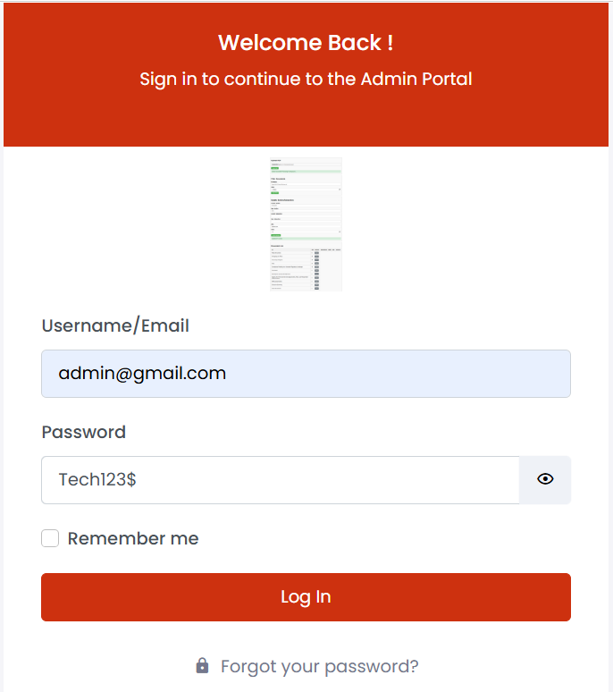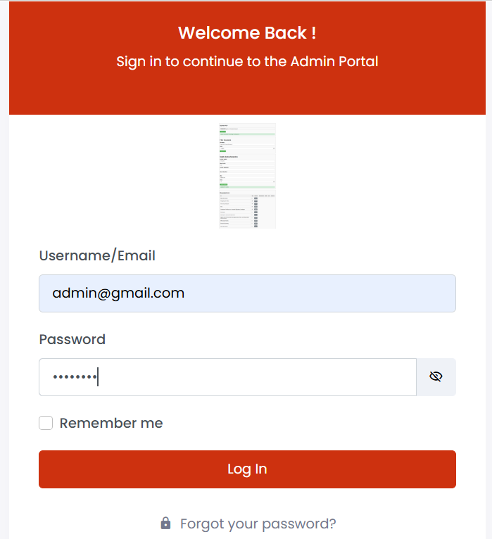

|  |  |  |  |  |  |  |  |  |  |
| --- | --- | --- | --- | --- | --- | --- | --- | --- | --- |
| **Sheet Name** | **Description** | **Test Steps** | **Expected Output** | **Original Status** | **TechPundits Test Results** | **TechPundits Comments** | **TechPundits Bug Fixes** | **Test Results Post Bug Fix** | **Comments Post Bug Fix** |
| ForgotReset Password | Verify entering the same password as the old password | 1. Navigate to the reset password page 2. Enter the user's current/old password in both fields 3. Click the submit button | 1. Form should not be submitted 2. A validation message should appear indicating that the new password cannot be the same as the old password 3. User should be prompted to choose a different password | **Pass** | **Fail** | Validation message appears when user's current /old password is entered in both fields. (after bug fix) - Has been tested locally only | **Fixed** | **Pass** | Validation message appears when user's current /old password is entered in both fields.- Has been tested locally only |

When new and old passwords are different, the password is reset successfully.

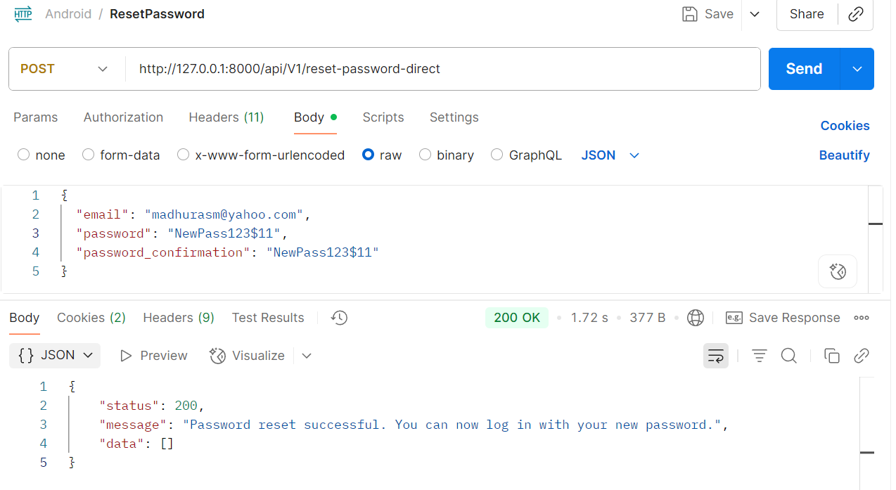

When new password is same as old password, it displays the message ‘New password cannot be the same as the old password.’

